Polynomial interpolation and comparison

Taylor Series Approximation
We can use the first few terms of a Taylor Series to approximating functions…[add more about Taylor series approximation]
Taylor series at $x_{0}$
$$p\left(x\right)=f\left(x_{0}\right)+f^{'}\left(x_{0}\right)\left(x-x_{0}\right)+\frac{f^{''}\left(x_{0}\right)}{2!}{\left(x-x_{0}\right)}^{2}+···$$

Example: Approximation of $f\left(x\right)\text{=}\frac{\text{1}}{x}\text{, }x\text{ ∈ [2,3]}$
– find the $n^{th}$ Taylor polynomial at $x=2.5$
$$p_{n}\left(x\right)=\frac{1}{2.5}+f^{'}\left(2.5\right)\left(x-2.5\right)+\frac{f^{''}\left(2.5\right)}{2!}{\left(x-2.5\right)}^{2}+\frac{f^{''}'\left(2.5\right)}{3!}{\left(x-2.5\right)}^{3}+···$$

Evaluating the values of the function and its derivatives at $x=2.5$
$$f\left(x\right)=\frac{1}{x} f\left(2.5\right)=\frac{1}{2.5}$$
$$f^{'}\left(x\right)=-\frac{1}{x^{2}} f^{'\left(2.5\right)}=-\frac{1}{{2.5}^{2}}$$
$$f^{''}\left(x\right)=\frac{2}{x^{3}} f^{''\left(2.5\right)}=\frac{2}{{2.5}^{3}}$$
$$f^{'''}\left(x\right)=-\frac{6}{x^{4}} f^{'''\left(2.5\right)}=-\frac{6}{{2.5}^{4}}$$

Therefore, the Taylor polynomials are as follows.
$$p_{0}\left(x\right)=f\left(2.5\right)=\frac{1}{2.5}$$
$$p_{1}\left(x\right)=f\left(2.5\right)+f^{'}\left(2.5\right)\left(x-2.5\right)$$
$$=\frac{1}{2.5}+\left(-\frac{1}{{2.5}^{2}}\right)\left(x-2.5\right)$$
$$=\frac{1}{2.5}-\frac{4}{25}\left(x-2.5\right)$$
$$p_{2}\left(x\right)=p_{1}\left(x\right)+\frac{f^{''}\left(2.5\right)}{2!}{\left(x-2.5\right)}^{2}$$
$$=\frac{1}{2.5}-\frac{4}{25}\left(x-2.5\right)+\frac{1}{{2.5}^{3}}{\left(x-2.5\right)}^{2}$$
$$=\frac{1}{2.5}-\frac{4}{25}\left(x-2.5\right)+\frac{8}{125}{\left(x-2.5\right)}^{2}$$
$$p_{3}\left(x\right)=p_{2}\left(x\right)+\frac{f^{''}'\left(2.5\right)}{3!}{\left(x-2.5\right)}^{3}$$
$$=\frac{1}{2.5}-\frac{4}{25}\left(x-2.5\right)+\frac{8}{125}{\left(x-2.5\right)}^{2}-\frac{16}{625}{\left(x-2.5\right)}^{3}$$

The four figures below compare the graphs of$P_{0}, P_{1}, P_{2},{ P}_{3}$with the graph of $f\left(x\right)=\frac{1}{x}$
Note that near $x=2.5$, the graphs are nearly indistinguishable.

$${ P}_{0} P_{1}$$
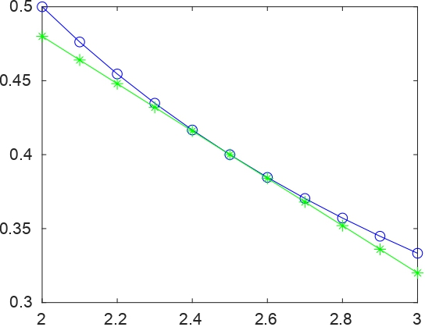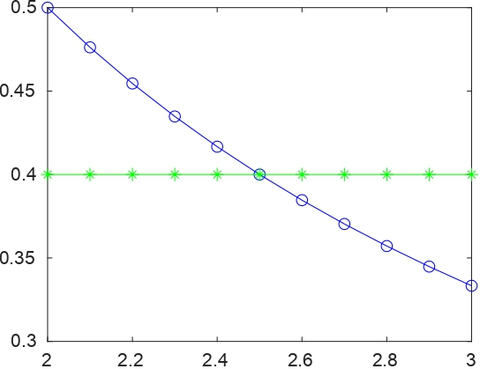

$$P_{2} P_{3}$$
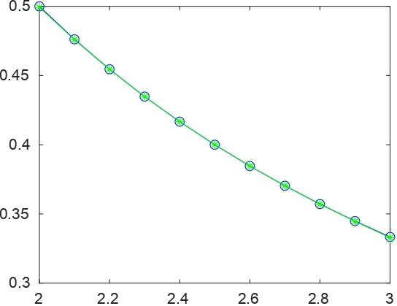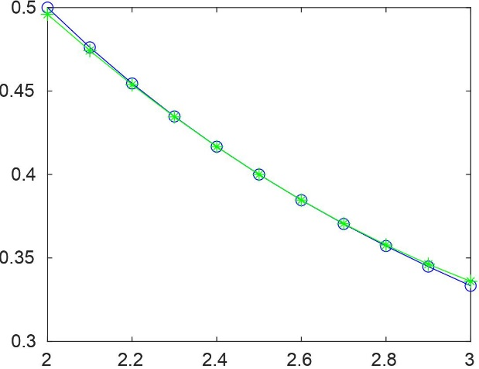

As $n$ increases, the graph of $p_{n}$becomes a better and better approximation of the graph
of $f\left(x\right)=\frac{1}{x}$ near $x=2.5.$[ add more explanation about the figures]
– plot$\left|f\left(x\right)-p_{n}\left(x\right)\right|$for $n=0, n=1, n=2,$and $n=3.$
For $n=0$
$$\left|f\left(x\right)-p_{0}\left(x\right)\right|=\left|\frac{1}{x}-\frac{1}{2.5}\right|$$
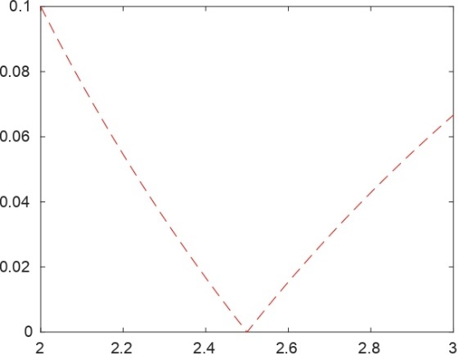
[ discuss observation]

For $n=1$
$$\left|f\left(x\right)-p_{1}\left(x\right)\right|=\left|\frac{1}{x}-\frac{1}{2.5}-\frac{4}{25}\left(x-2.5\right)\right|$$
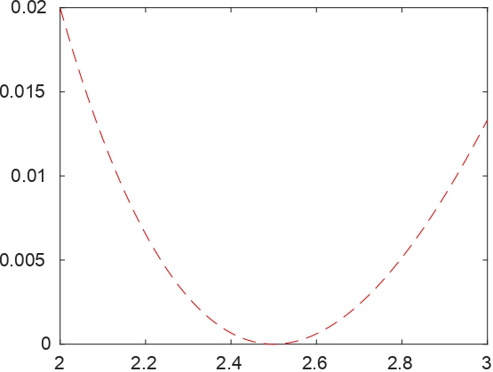
[ discuss observation]

For $n=2$
$$\left|f\left(x\right)-p_{2}\left(x\right)\right|=\left|\frac{1}{x}-\frac{1}{2.5}-\frac{4}{25}\left(x-2.5\right)+\frac{8}{125}{\left(x-2.5\right)}^{2}\right|$$
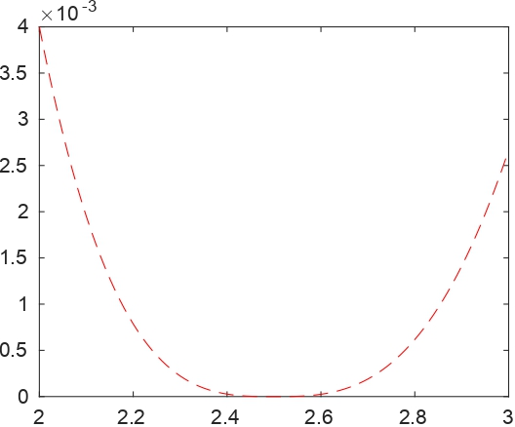
[ discuss observation]

For $n=3$
$$\left|f\left(x\right)-p_{3}\left(x\right)\right|=\left|\frac{1}{x}-\frac{1}{2.5}-\frac{4}{25}\left(x-2.5\right)+\frac{8}{125}{\left(x-2.5\right)}^{2}-\frac{16}{625}{\left(x-2.5\right)}^{3}\right|$$
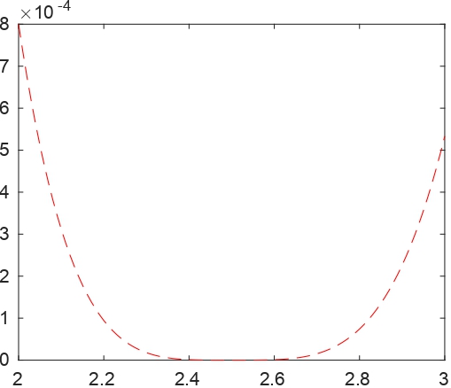
[ discuss observation]

– Measure the error at $z=2 :h :3$ with $h= 0.01$, plot the relative error in $2$ norm versus n, where relative error in $2$ norm is

$$E=\frac{\sqrt{\sum_{i=1}^{N}{{\left(f\left(z_{i}\right)-p_{n}\left(z_{i}\right)\right)}^{2}}}}{\sqrt{\sum_{i=1}^{N}{{f\left(z_{i}\right)}^{2}}}}$$

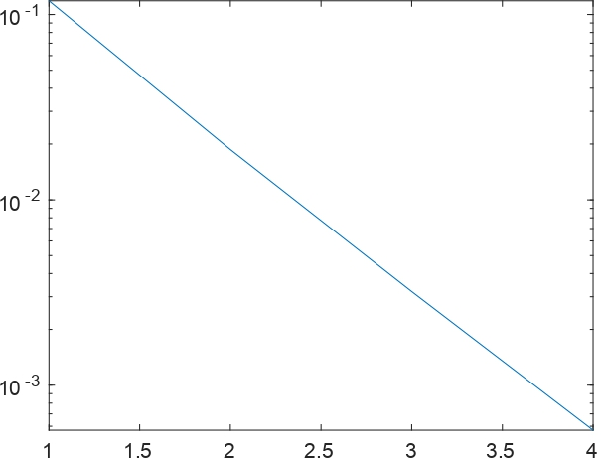
[ discuss observation]

Lagrange Polynomials
Lagrange polynomials are used for polynomial interpolation. [add more about Lagrange polynomials]
The $nth$ Lagrange Integrating Polynomial
$$P\left(x\right)= f \left(x_{0}\right)L_{n,0}\left(x\right)+ · · · + f \left(x_{n}\right)L_{n,n}\left(x\right)=\sum_{k=0}^{n}{f\left(x_{k}\right)L_{n,k}\left(x\right)}$$
where, for each $k=0, 1, …,n,$
$$L_{n,k}\left(x\right)=\frac{(x-x_{0})(x-x_{1})···(x-x_{k-1})(x-x_{k+1})···(x-x_{n})}{(x_{k}-x_{0})(x_{k}-x_{1})···(x_{k}-x_{k-1})(x_{k}-x_{k+1})···(x_{k}-x_{n})}$$

Example: $f\left(x\right) \text{=}\frac{\text{1}}{x}\text{, }x \text{∈}\text{ [2,3]}$
– write down the Lagrange interpolation formula for $n= 2$ and $n= 3.$
For $n=2$
$${ P}_{2}\left(x\right)=\sum_{k=0}^{2}{f\left(x_{k}\right)l_{k}\left(x\right)}=f\left(x_{0}\right){l_{0}\left(x\right)+f\left(x_{1}\right)l}_{1}\left(x\right)+f\left(x_{2}\right)l_{2}\left(x\right)$$

where
$$l_{0}\left(x\right)=\frac{\left(x-x_{1}\right)\left(x-x_{2}\right)}{\left(x_{0}-x_{1}\right)\left(x_{0}-x_{2}\right)}$$
$$l_{1}\left(x\right)=\frac{\left(x-x_{0}\right)\left(x-x_{2}\right)}{\left(x_{1}-x_{0}\right)\left(x_{1}-x_{2}\right)}$$
$${\begin{aligned} \\ l\end{aligned}}_{2}\left(x\right)=\frac{\left(x-x_{0}\right)\left(x-x_{1}\right)}{\left(x_{2}-x_{0}\right)\left(x_{2}-x_{1}\right)}$$

For $n=3$
$${ P}_{3}\left(x\right)=\sum_{k=0}^{3}{f\left(x_{k}\right)l_{k}\left(x\right)}=f\left(x_{0}\right){l_{0}\left(x\right)+f\left(x_{1}\right)l}_{1}\left(x\right)+f\left(x_{2}\right)l_{2}\left(x\right)+f\left(x_{3}\right)l_{3}\left(x\right)$$

where
$$l_{0}\left(x\right)=\frac{\left(x-x_{1}\right)\left(x-x_{2}\right)\left(x-x_{3}\right)}{\left(x_{0}-x_{1}\right)\left(x_{0}-x_{2}\right)\left(x_{0}-x_{3}\right)}$$
$$l_{1}\left(x\right)=\frac{\left(x-x_{0}\right)\left(x-x_{2}\right)\left(x-x_{3}\right)}{\left(x_{1}-x_{0}\right)\left(x_{1}-x_{2}\right)\left(x_{1}-x_{3}\right)}$$
$$l_{2}\left(x\right)=\frac{\left(x-x_{0}\right)\left(x-x_{1}\right)\left(x-x_{3}\right)}{\left(x_{2}-x_{0}\right)\left(x_{2}-x_{1}\right)\left(x_{2}-x_{3}\right)}$$
$$l_{3}\left(x\right)=\frac{\left(x-x_{0}\right)\left(x-x_{1}\right)\left(x-x_{2}\right)}{\left(x_{3}-x_{0}\right)\left(x_{3}-x_{1}\right)\left(x_{3}-x_{2}\right)}$$

– plot $P_{n}\left(x\right)$to approximate $f\left(x\right)\text{ =}\frac{\text{1}}{x}\text{ in [2,3]}$ and the error $\left|f\left(x\right)-P_{n}\left(x\right)\right|$
For $n=2,3$

For $n=2$, take $x_{0}=2, x_{1}=2.5, x_{2}=3$
To find the Lagrange polynomial of degree 2, first find the value of $l_{0}\left(x\right),$ $l_{1}\left(x\right)$ and $l_{2}\left(x\right)$
$$l_{0}\left(x\right)=\frac{\left(x-2.5\right)\left(x-3\right)}{\left(2-2.5\right)\left(2-3\right)}= 2\left(x-2.5\right)\left(x-3\right)$$
$$l_{1}\left(x\right)=\frac{\left(x-2\right)\left(x-3\right)}{\left(2.5-2\right)\left(2.5-3\right)}=-4\left(x-2\right)\left(x-3\right)$$
$${\begin{aligned} \\ l\end{aligned}}_{2}\left(x\right)=\frac{\left(x-2\right)\left(x-2.5\right)}{\left(3-2\right)\left(3-2.5\right)}=2\left(x-2\right)\left(x-2.5\right)$$
also
$$f\left(x_{0}\right)=f\left(2\right)=\frac{1}{2}, f\left(x_{1}\right)=f\left(2.5\right)=\frac{1}{2.5}, f\left(x_{2}\right)=f\left(3\right)=\frac{1}{3}$$
Therefore, the Lagrange interpolating polynomial,$P_{2}\left(x\right)$is given by
$$P_{2}\left(x\right)=\left(x-2.5\right)\left(x-3\right)-\frac{8}{5}\left(x-2\right)\left(x-3\right)+\frac{2}{3}\left(x-2\right)\left(x-2.5\right)$$
$$=\frac{1}{15}x^{2}-\frac{1}{2}x+\frac{37}{30}$$
solid line: f(x), given function
dashed line: pn(x), interpolating polynomial

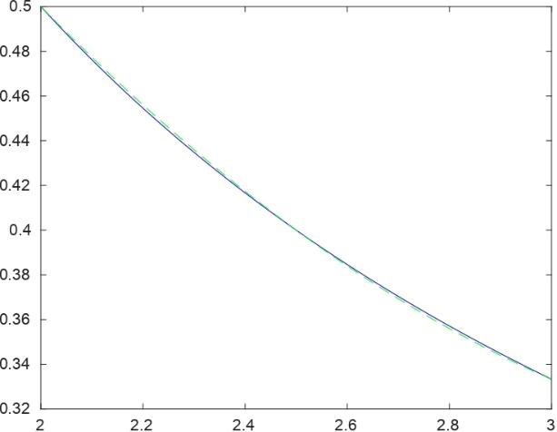

[ discuss observation]

The error$\left|f\left(x\right)-P_{2}\left(x\right)\right| is$
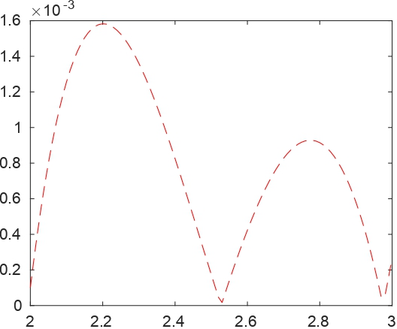
[ discuss observation]

For $n=3$, take${ x}_{0}=2,$ $x_{1}=2+1/3, x_{2}=2+2/3, x_{3}=3$
To find the Lagrange polynomial of degree 3, first find the value of $l_{0}\left(x\right),$ $l_{1}\left(x\right),$ $l_{2}\left(x\right)$ and$l_{3}\left(x\right)$
$$l_{0}\left(x\right)=\frac{\left(x-\frac{7}{3}\right)\left(x-\frac{8}{3}\right)(x-3)}{\left(2-\frac{7}{3}\right)\left(2-\frac{8}{3}\right)(2-3)}=-\frac{9}{2}\left(\left(x-\frac{7}{3}\right)\left(x-\frac{8}{3}\right)(x-3)\right)$$
$$l_{1}\left(x\right)=\frac{\left(x-2\right)\left(x-\frac{8}{3}\right)(x-3)}{\left(\frac{7}{3}-2\right)\left(\frac{7}{3}-\frac{8}{3}\right)\left(\frac{7}{3}-3\right)}=\frac{27}{2}\left(\left(x-2\right)\left(x-\frac{8}{3}\right)(x-3)\right)$$
$$l_{2}\left(x\right)=\frac{\left(x-2\right)\left(x-\frac{7}{3}\right)(x-3)}{\left(\frac{8}{3}-2\right)\left(\frac{8}{3}-\frac{7}{3}\right)\left(\frac{8}{3}-3\right)}=-\frac{27}{2}\left(\left(x-2\right)\left(x-\frac{7}{3}\right)(x-3)\right)$$
$$l_{3}\left(x\right)=\frac{\left(x-2\right)\left(x-\frac{7}{3}\right)\left(x-\frac{8}{3}\right)}{\left(3-2\right)\left(3-\frac{7}{3}\right)\left(3-\frac{8}{3}\right)}=\frac{9}{2}\left(\left(x-2\right)\left(x-\frac{7}{3}\right)\left(x-\frac{8}{3}\right)\right)$$
also
$$f\left(x_{0}\right)=f\left(2\right)=\frac{1}{2}, f\left(x_{1}\right)=f\left(\frac{7}{3}\right)=\frac{3}{7}, f\left(x_{2}\right)=f\left(\frac{8}{3}\right)=\frac{3}{8}, f\left(x_{3}\right)=f\left(3\right)=\frac{1}{3}$$
Therefore, the Lagrange interpolating polynomial,$P_{3}\left(x\right)$is given by
$$P_{3}\left(x\right)=\frac{9}{4}\left(\left(x-\frac{7}{3}\right)\left(x-\frac{8}{3}\right)\left(x-3\right)\right)+\frac{81}{14}\left(\left(x-2\right)\left(x-\frac{8}{3}\right)\left(x-3\right)\right)-\frac{81}{16}\left(\left(x-2\right)\left(x-\frac{7}{3}\right)\left(x-3\right)\right)+\frac{3}{2}\left(\left(x-2\right)\left(x-\frac{7}{3}\right)\left(x-\frac{8}{3}\right)\right)$$

$$=-\frac{3}{112}x^{3}+\frac{15}{56}x^{2}-\frac{335}{336}x+\frac{275}{168}$$
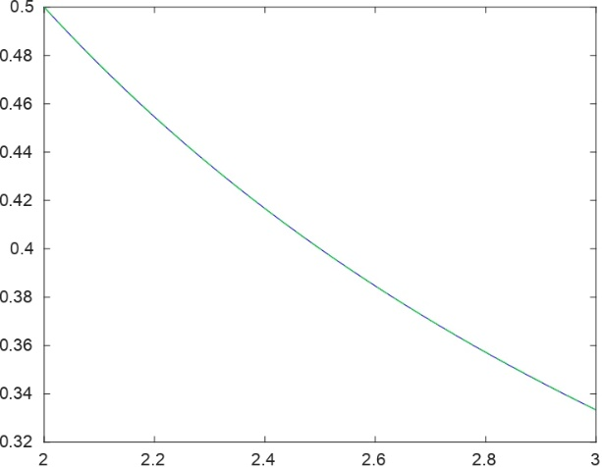
[ discuss observation]

The error$\left|f\left(x\right)-P_{3}\left(x\right)\right| is$
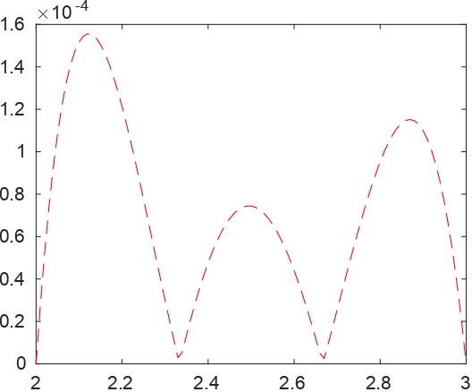
[ discuss observation]

–plot relative error versus n
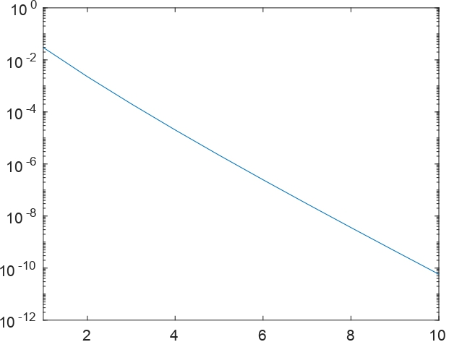
[ discuss observation]

Interpolation at the uniform points and Chebyshev points
[add introduction about the topic]

$$- f\left(x\right) \text{=}\frac{\text{1}}{x}\text{, }x \text{∈}\text{ [2,3]}$$

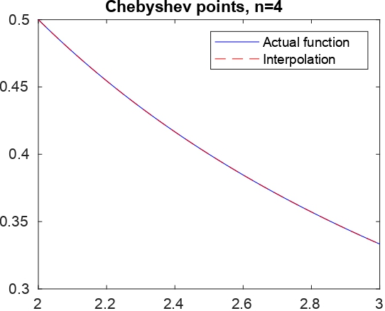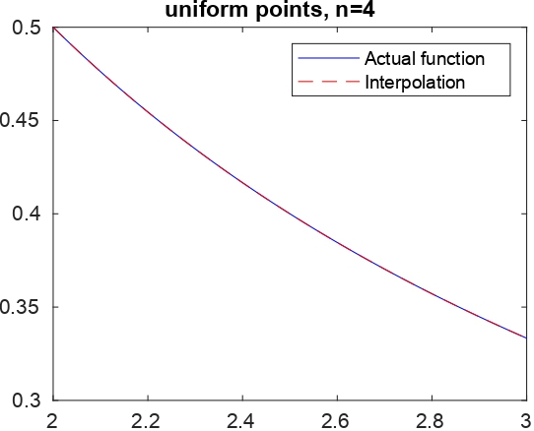

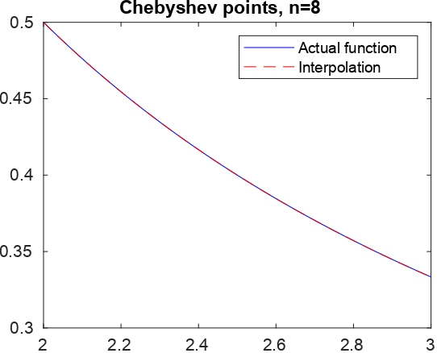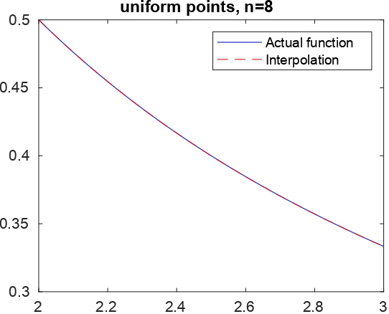

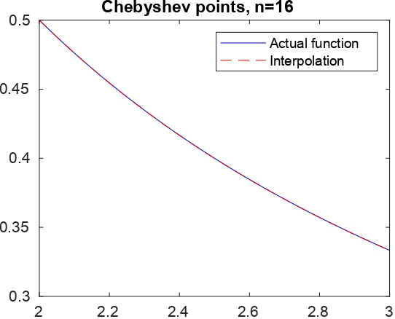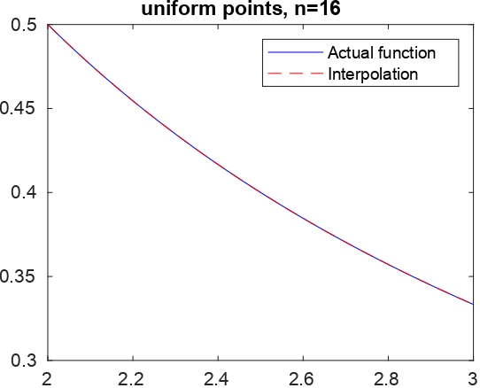
[ discuss observation]

Other Functions
[little intro]
$$f\left(x\right)=x^{20} , -1≤x≤1$$

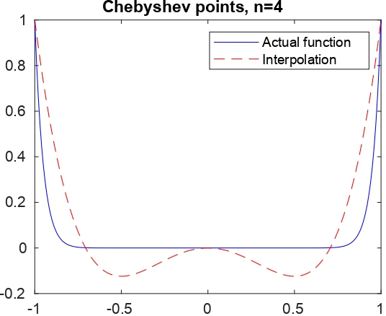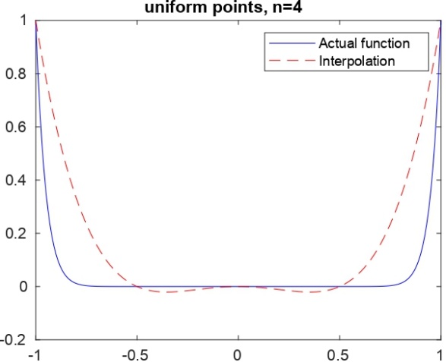

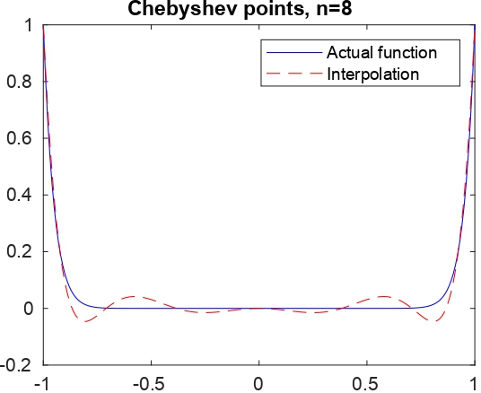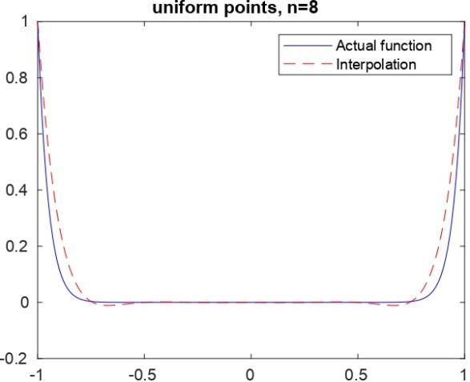

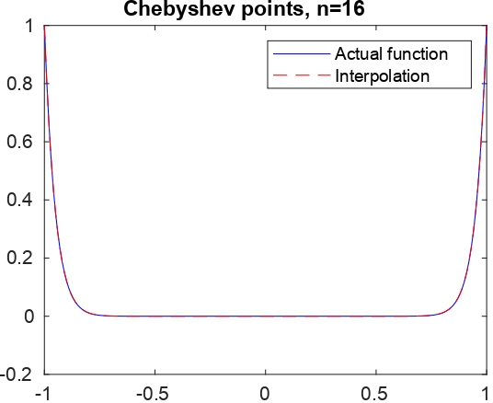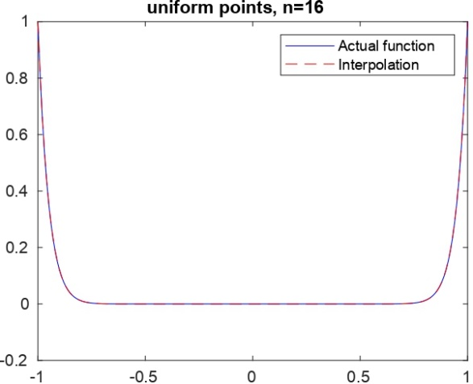

[ discuss observation]

The relative error versus n from 1 to 10 with uniform points and Chebyshev points

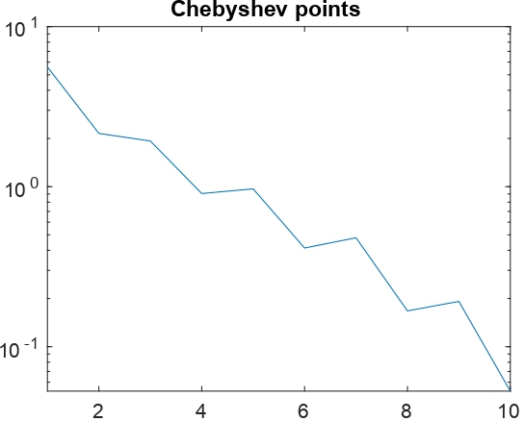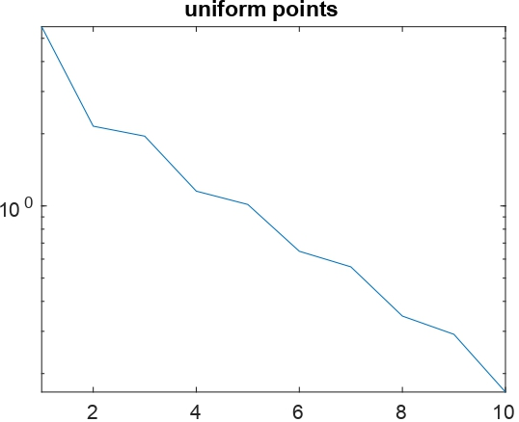
[ discuss observation]

$$f\left(x\right)=e^{x} , -1≤x≤1$$

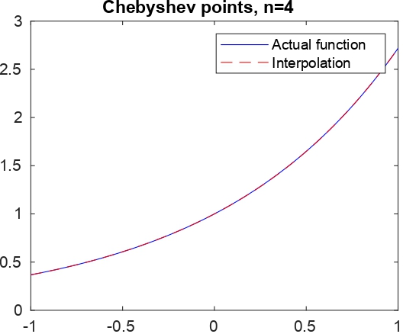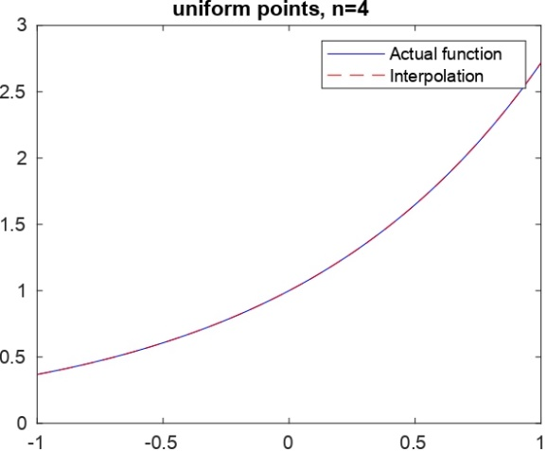

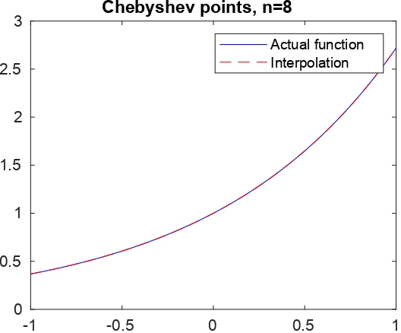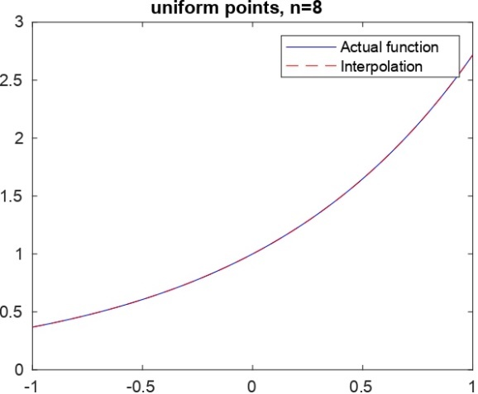

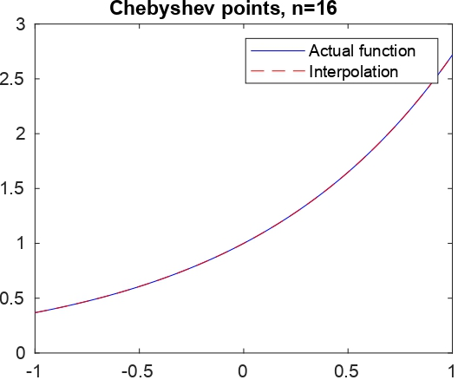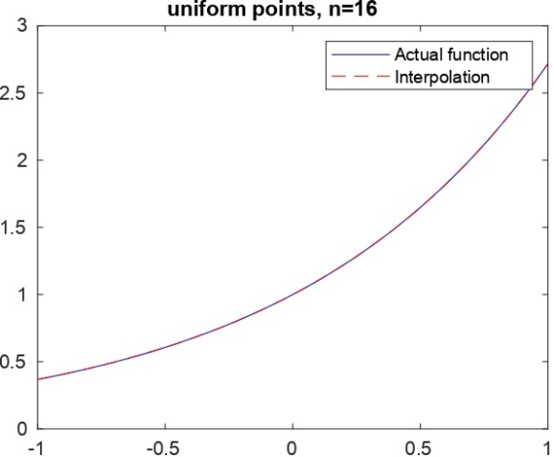
[ discuss observation]
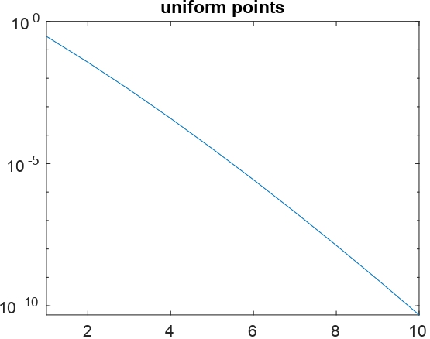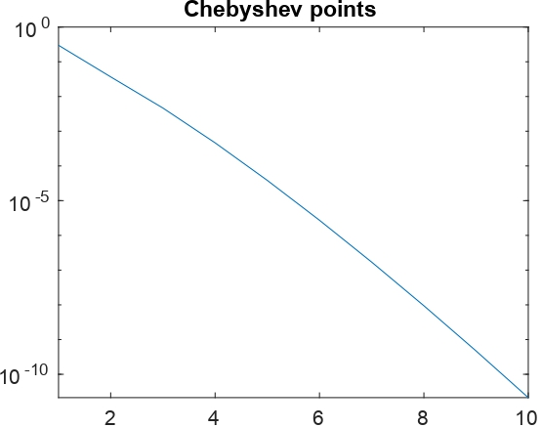
[ discuss observation]

$$f\left(x\right)=e^{{-x}^{2}} , -1≤x≤1$$

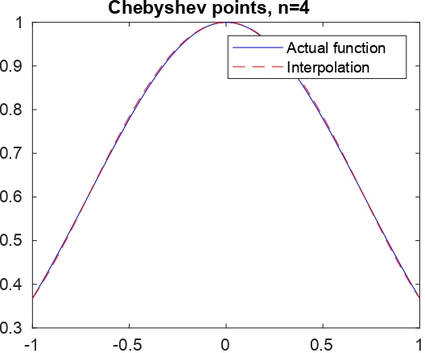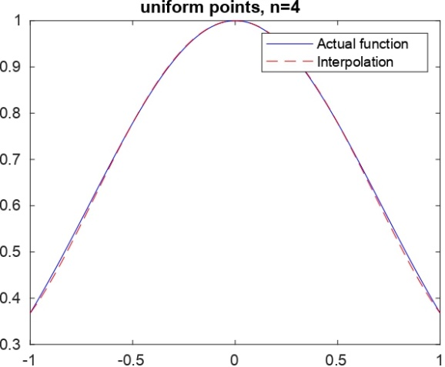

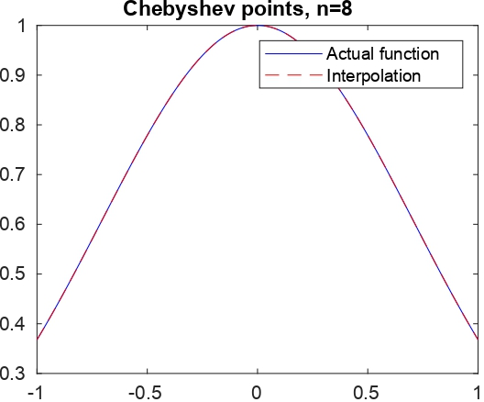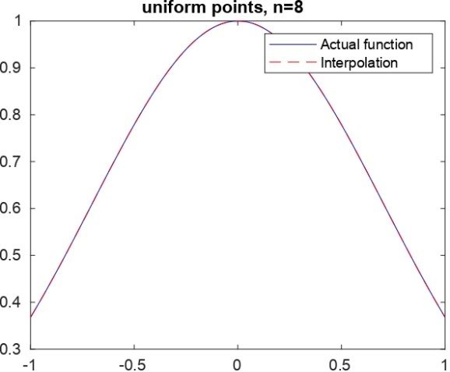

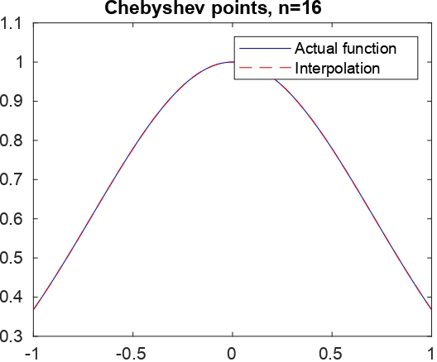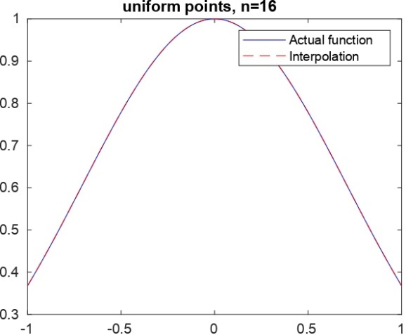
[ discuss observation]
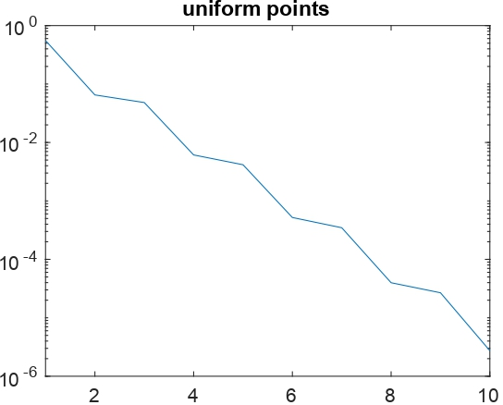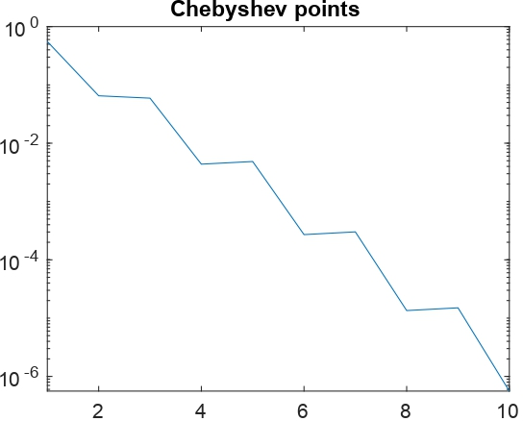
[ discuss observation]
$$f\left(x\right)=\frac{1}{1+16x^{2}} , -1≤x≤1$$

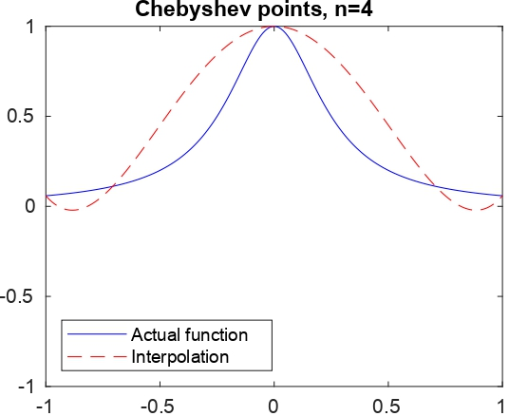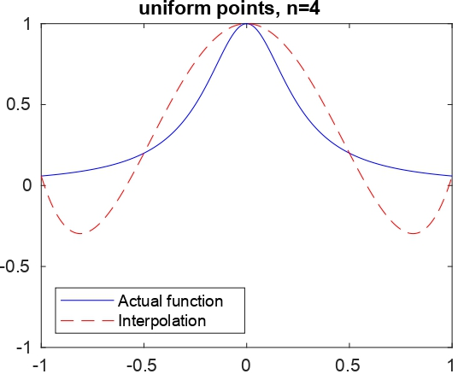

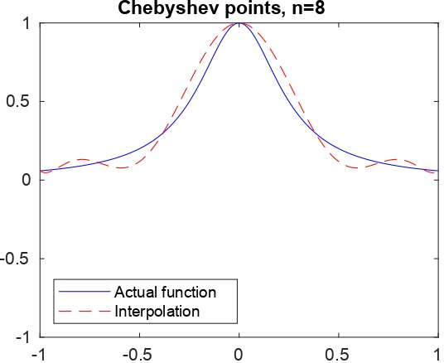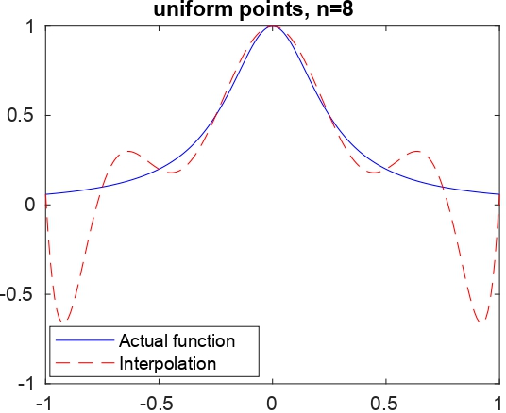

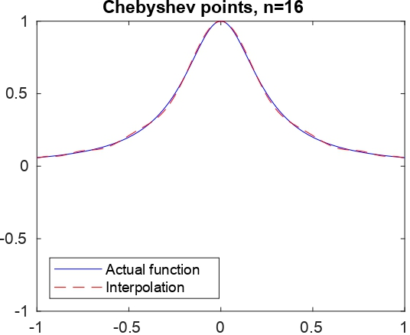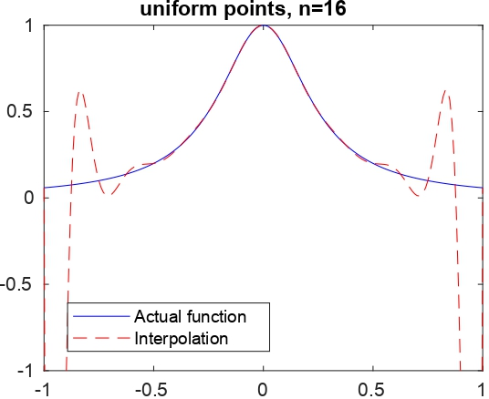
[ discuss observation]

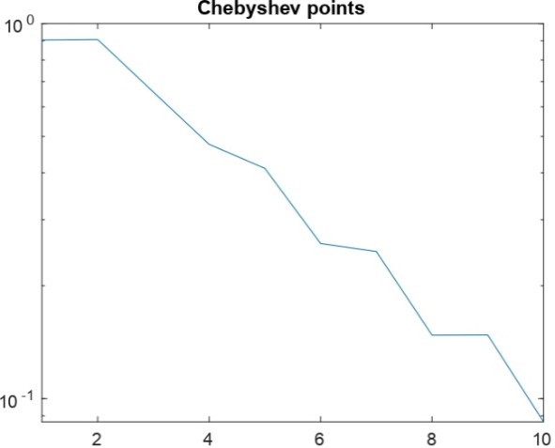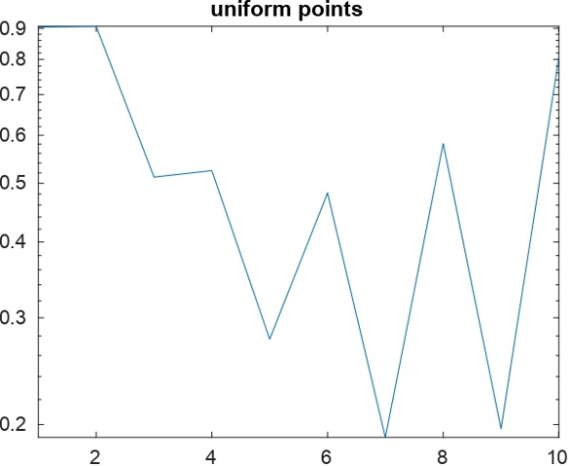
[ discuss observation]

$$f\left(x\right)=e^{-1/x^{2}} , -1≤x≤1$$

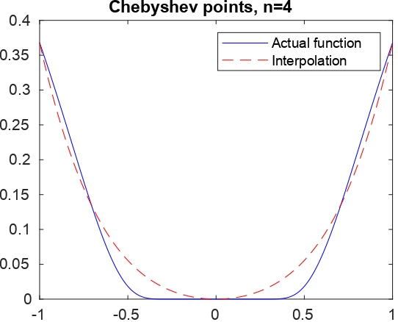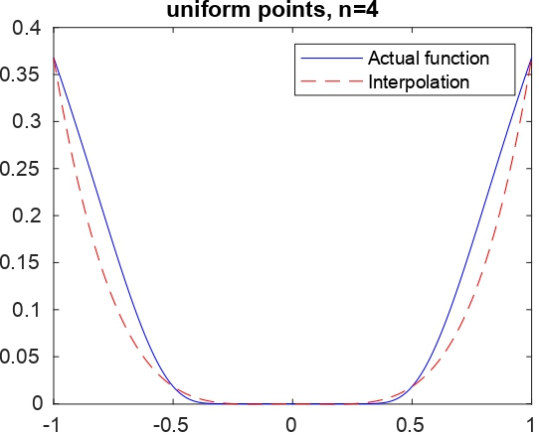

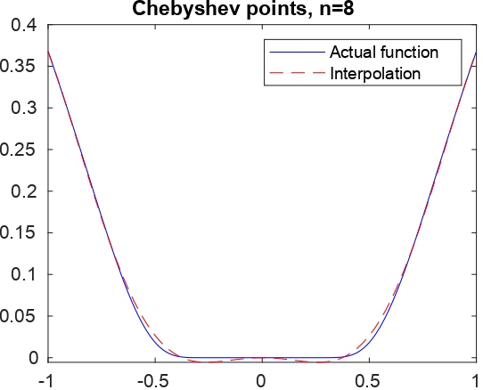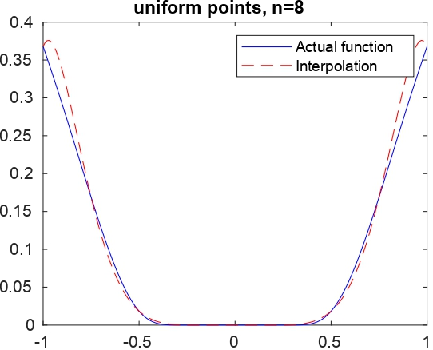

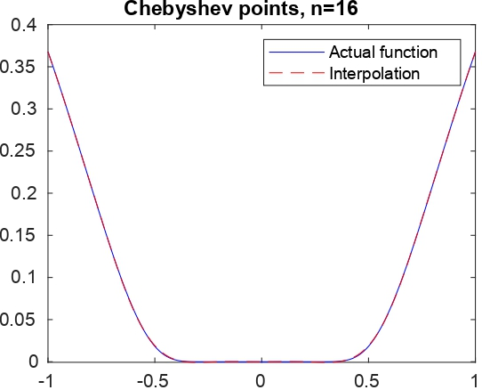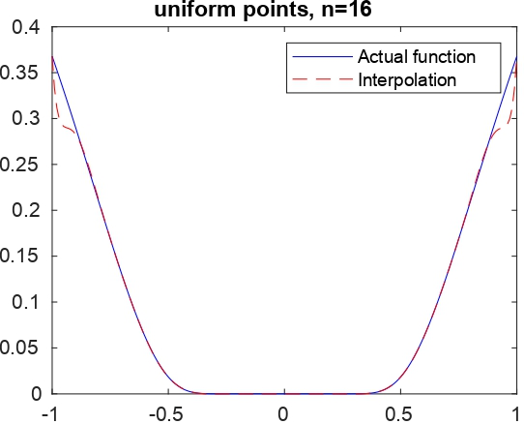
[ discuss observation]
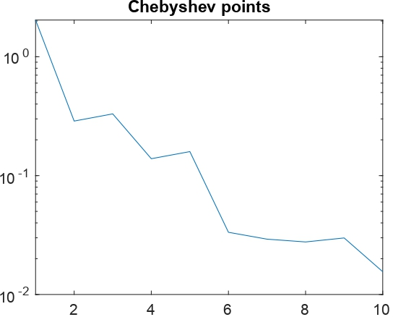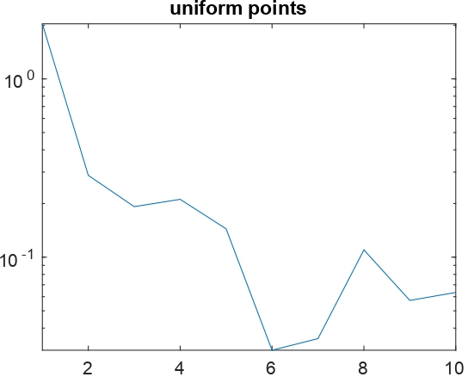
[ discuss observation]

$$f\left(x\right)={\left|x\right|}^{3} , -1≤x≤1$$

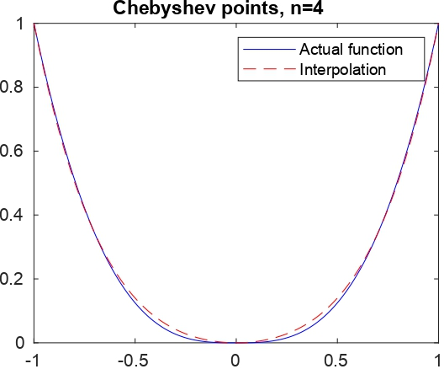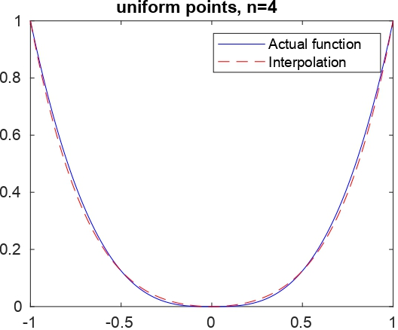

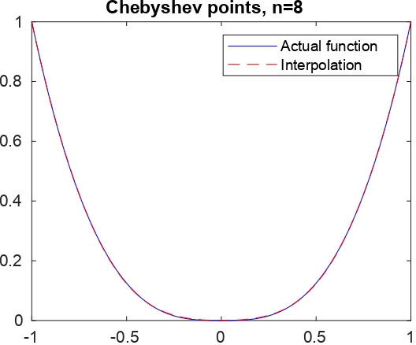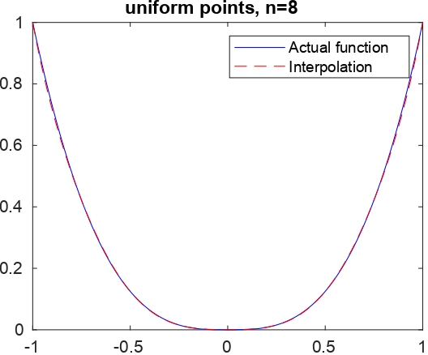

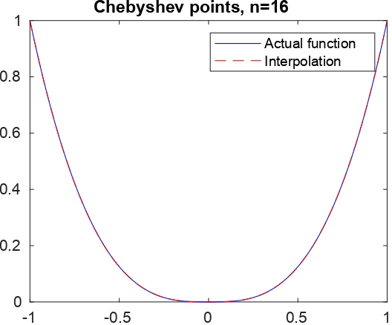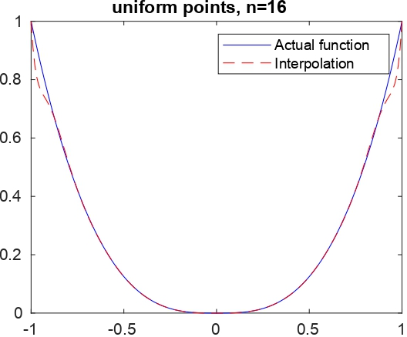
[ discuss observation]

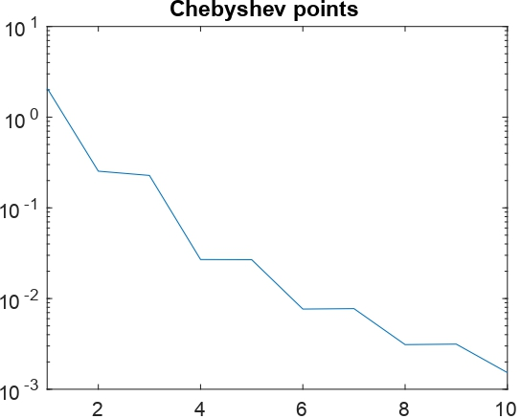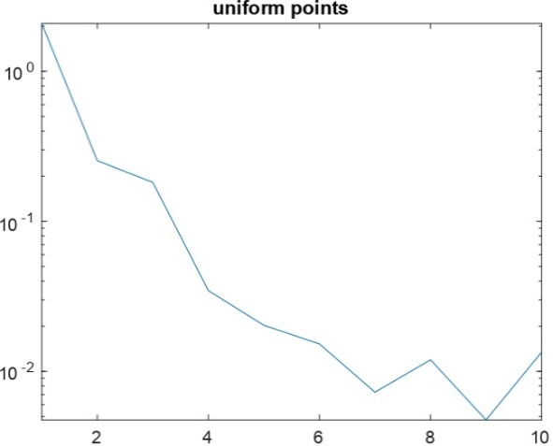
[ discuss observation]
An example of the code
clear
e=[];
for n=1:10
a = -1; % left end of the interval
b = 1; % right end of the interval
h = (b - a)/n; % interpolation grid size
t = a:h:b; % interpolation points
f = abs(t).^3 % This is the function evaluated at interpolation points
%%%% pn(x) = \sum f(t_i)l_i(x)
hh = 0.01; % grid to plot the function both f and p
x = a:hh:b;
fexact = abs(x).^3 ; %exact function f at x
l = zeros(n+1, length(x)); %%%% l(1,:): l_0(x), ..., l(n+1): l_n(x)
nn = ones(n+1, length(x));
d = ones(n + 1, length(x));

for i = 1:n+1
for j = 1:length(x)
nn(i,j) = 1;
d(i,j) = 1;
for k = 1:n+1
if i ~= k
nn(i,j) = nn(i,j) * (x(j) - t(k));
d(i,j) = d(i,j) * (t(i) - t(k));
end
end
l(i,j) = nn(i,j)/d(i,j);
end
end

fapp = zeros(length(x),1);
for j = 1:length(x)
for i=1:n+1
fapp(j) = fapp(j) + f(i)*l(i,j);
end
end
En = 0;
Ed = 0;
for i = 1:length(x)
Ed = Ed + fexact(i)^2;
En = En + (fexact(i) - fapp(i))^2;
end
Ed = sqrt(Ed);
En = sqrt(En);
E = En/Ed
e=[e;E];
semilogy(e);

title(sprintf(' uniform points'))

end

